Treetops

Resource Booking System

User Guide

Contents

Introduction 3

Basic Functions 4

Logging In 4

Logging in as Guest 4

Viewing Today’s Bookings 5

Making a Booking 6

Finding a Resource 6

Navigating the Timetable 7

Creating a Booking 7

Booking Descriptions 8

Restricted Resources 9

Undoing a Booking 10

Managing Bookings 10

Recurring Bookings 11

Creating a Recurring Booking 11

Managing Recurring Bookings 13

Logging Out 14

# Introduction

This is a user guide for the Treetops Resource Booking System on the school’s intranet. It is a tool for booking resources, such as rooms, vehicles and IT equipment, and displaying these bookings in a calendar format.

This user guide aims to explain how to use the software, such as logging in, making a booking, and deleting a booking.

# Basic Functions

## Logging In

To use the system, you must be on a computer that is connected to the Treetops network. The tool runs locally, so it is not possible to use it outside of the school’s network.

First, navigate to the following address:

[*http://ttwin10/*](http://ttwin10/)

You should be presented with the login page *(Figure 1).*

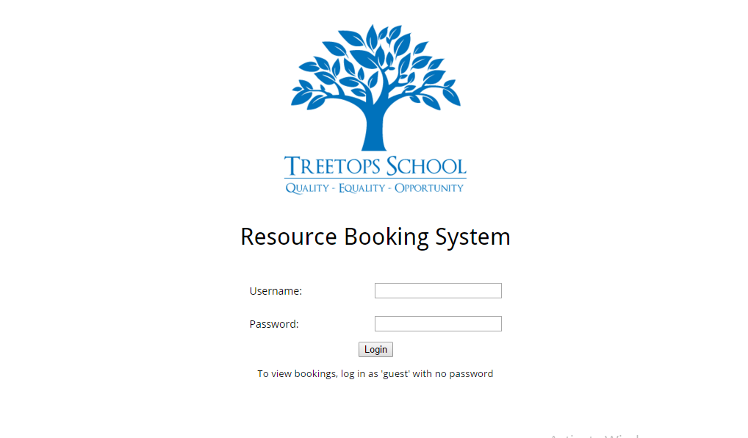

*Figure 1: The login screen*

The next step is to enter your username and password. Your username is set as your first initial, followed by your surname. By default, your password is the same. So, as an example, if my name were *John Green*, I would log in as:

Username: jgreen

Password: jgreen

Once you have entered this, simply press the ‘Login’ button and you should be successfully logged in.

## Logging in as Guest

If you do not plan to make any bookings, and would simply like to view the timetable of bookings, you may wish to log in as a guest. As stated on the login screen this can be done using the following:

Username: guest

Password: [none]

Functionality is limited when logged in as guest.

## Viewing Today’s Bookings

Having logged in, you are presented with the homepage. Here is where you will find information about today, and any bookings you have for today. If you have not made any bookings for today, it should look like it does in *Figure 2*.

If you have made a booking, and that booking is for today, you should see a reminder of this fact, as shown in *Figure 3*.

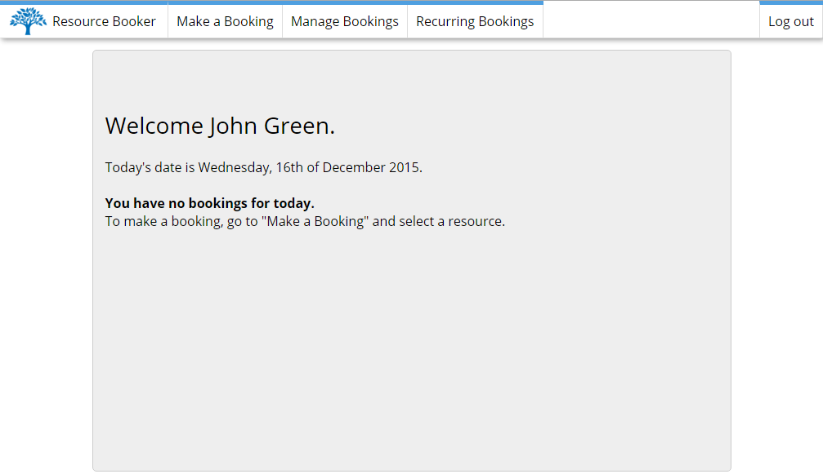

*Figure 2: The homepage, if you have no bookings for today*

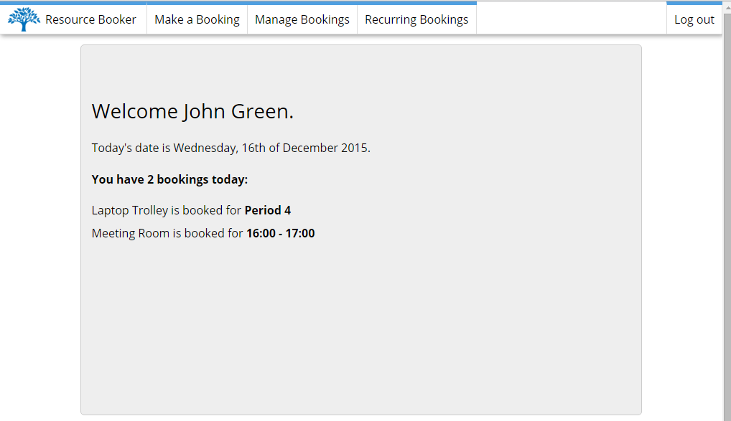

*Figure 3: The homepage, showing bookings you have today*

If you want to return to the homepage, you can navigate here by clicking the ‘Resource Booker’ link in the top left corner, or the Treetops logo.

# Making a Booking

## Finding a Resource

To make a booking for a resource, simply hover over the *Make a Booking* item in the navigation menu. You should be presented with a drop-down list of resource types, such as *Rooms* and *Vehicles*. Hover over the type of resource you wish to book, and you will be presented with a sub-menu of resources. Click a resource to navigate to its booking page. Refer to *Figure 4* to see the menu system.

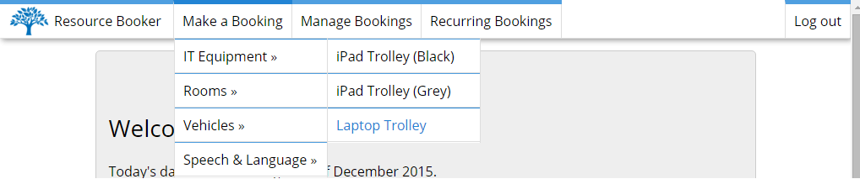

*Figure 4: The menu system. This is reached through Make a Booking » IT Equipment » Laptop Trolley*

Having clicked the resource you would like to book, you will be sent to the page for that resource. *(Figure 5)*

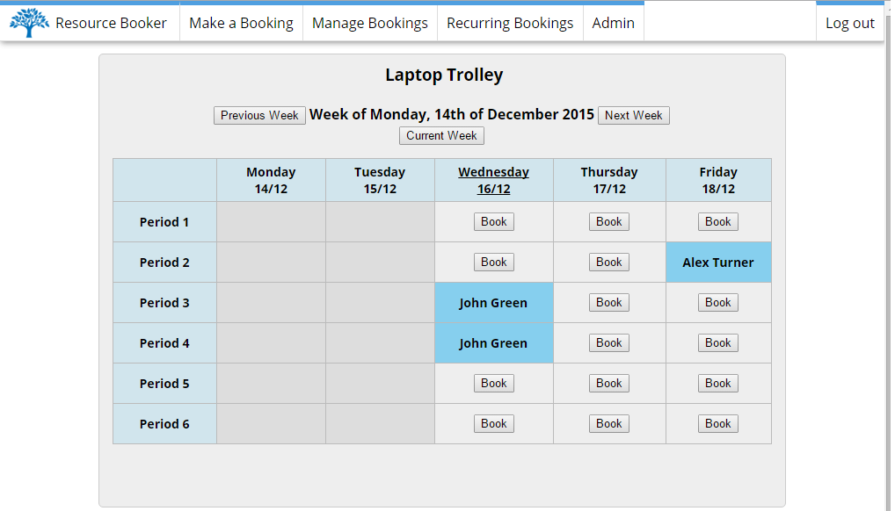

*Figure 5: A resource booking page*

## Navigating the Timetable

When you first navigate to a resource booking page, you will be shown the availability for the current week (Refer to *Figure 5*), with today’s date underlined.

Any bookings already made will be shown in blue on the timetable, along with the name of the person who booked it, and hence cannot be booked.

Any periods in the past are greyed out, and cannot be booked.

All periods available for booking have a button labelled ‘Book’ on them.

The timetable can be navigated using the three buttons above the timetable: ‘Next Week’, ‘Previous Week’, and ‘Current Week’. These can be used to navigate forwards or backwards through the weeks. Pressing ‘Current Week’ will reset back to the current week.

## Creating a Booking

To create a booking, simply press the ‘Book’ button on the period you would like to book.

Having pressed the button, you will be presented with an alert, asking you to confirm the details of the booking *(Figure 6)*. Note that this alert will appear differently on different browsers.

Ensure that the details of the booking are correct before proceeding and pressing ‘Ok’.

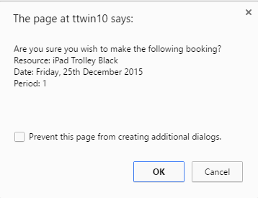

*Figure 6a: Confirmation box in Google Chrome*

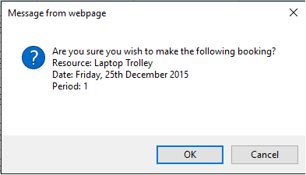

*Figure 6b: Confirmation box in Internet Explorer*

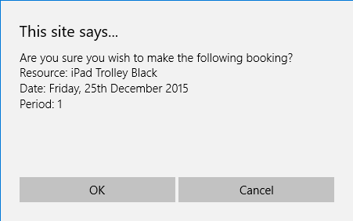

*Figure 6c: Confirmation box in Microsoft Edge*

## Booking Descriptions

When booking either a room or a vehicle, you will be required to give a description of the booking. This is to let everybody else know what the booking is for. When booking one of these resources, you will be presented with a textbox in which you should give a short description of the reason for the booking *(See Figure 7)*. Note that the appearance of this prompt may vary between browsers.

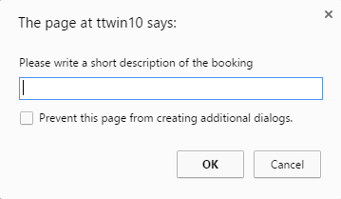

*Figure 7: The box in which to write the description of the booking*

To view the reason for a booking, you can simply hover over the booking in the timetable, and the text should change from the name of the person who made the booking, to the description of the booking. This is shown in *Figure 8*.

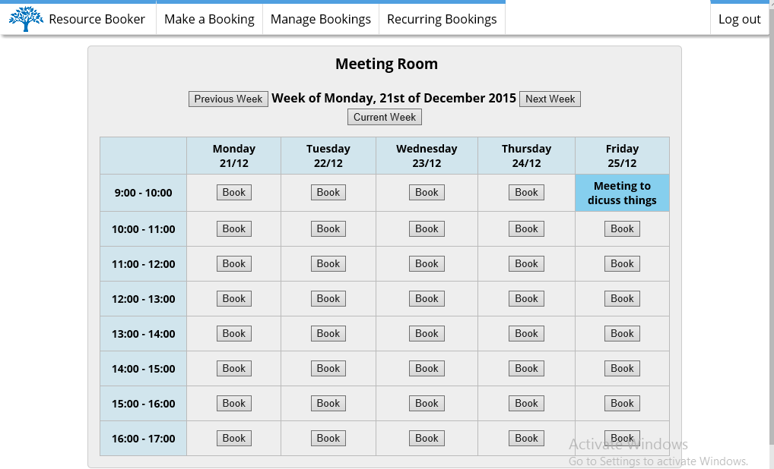

*Figure 8: Showing the description of the booking, by hovering the mouse over the booking*

## Restricted Resources

Certain resources are restricted, and therefore can only be booked by certain people. Presently, these resources are vehicles, and Speech & Language resources. When a user who does not have the correct permissions selects one of these resources, they will see what is shown in *Figure 9*.

Note that those without the permissions to book a resource are still allowed to *view* bookings.

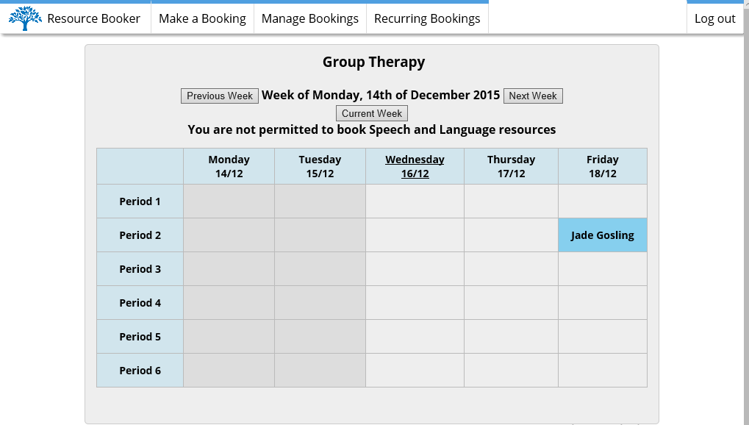

*Figure 9: Showing a resource where the user does not have permission to book it*

## Undoing a Booking

Having successfully made a booking, you should see your booking appear in the timetable, as well as some text appearing at the top of the page *(Figure 7)*. This tells you that the booking has been made, and gives you the option ‘Undo’ and ‘Dismiss’

Pressing ‘Dismiss’ just gets rid of this text message.

Pressing ‘Undo’ will completely undo the booking you just made.

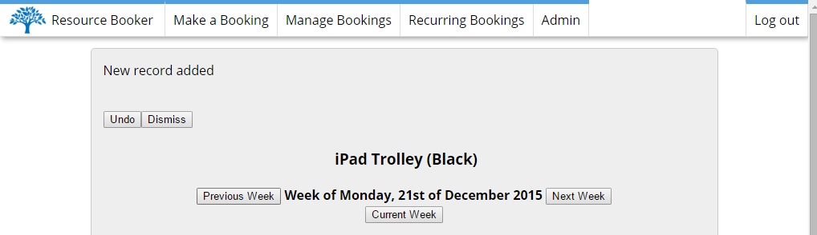

*Figure 10: The text message, with the Undo and Dismiss buttons*

# Managing Bookings

You may wish to see all of your bookings in one page. To do this, simply click the ‘Manage Bookings’ item in the navigation menu. This will take you to the Manage Bookings page *(Figure 8).*

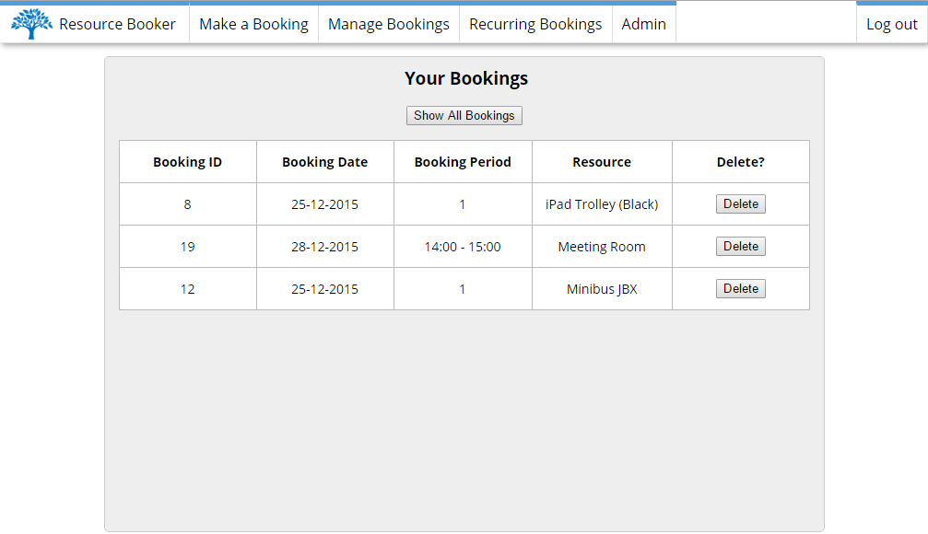

*Figure 11: Manage Bookings page*

Here, you are presented with all of your active bookings, that is to say, any bookings that have not already happened. It is possible to delete each one individually by pressing the ‘Delete’ button next to the record. It is possible to view *every* booking you have made, past and active, by pressing the ‘Show All Bookings’ button. This switches the view to ‘All’ *(Figure 9)*.

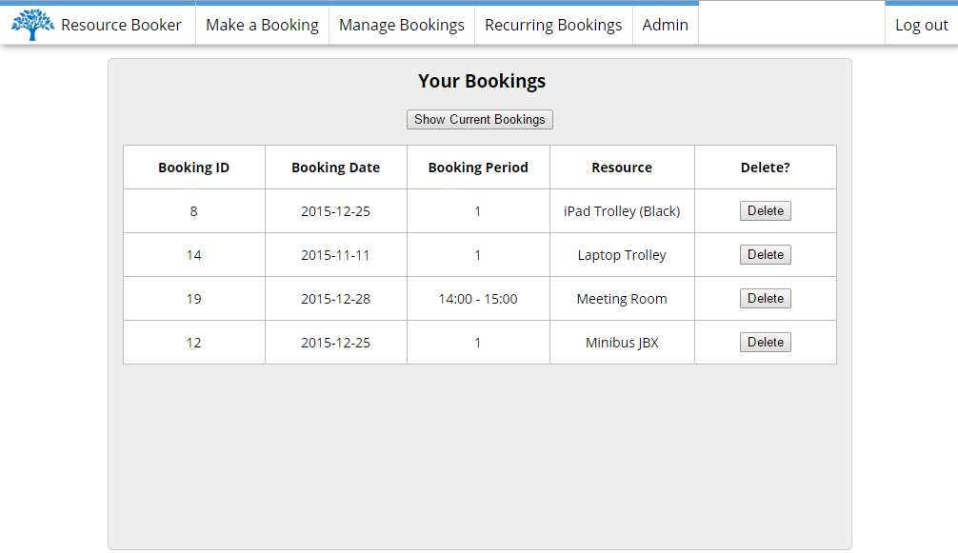

*Figure 12: Manage Bookings page, showing all bookings*

You can switch back to the other view by pressing ‘Show Current Bookings’.

# Recurring Bookings

## Creating a Recurring Booking

It is possible to create a recurring booking for a resource. This is done by selecting the Create item in the Recurring Bookings list in the navigation menu *(Figure 10)*.

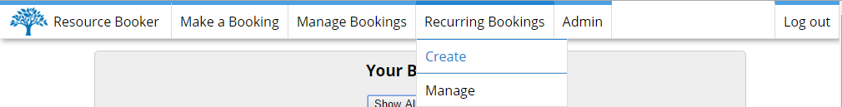

*Figure 13: The menu system where you can create a Recurring Booking*

Having pressed Create, you will be presented with a form to enter the information for the recurrence *(Figure 11).*

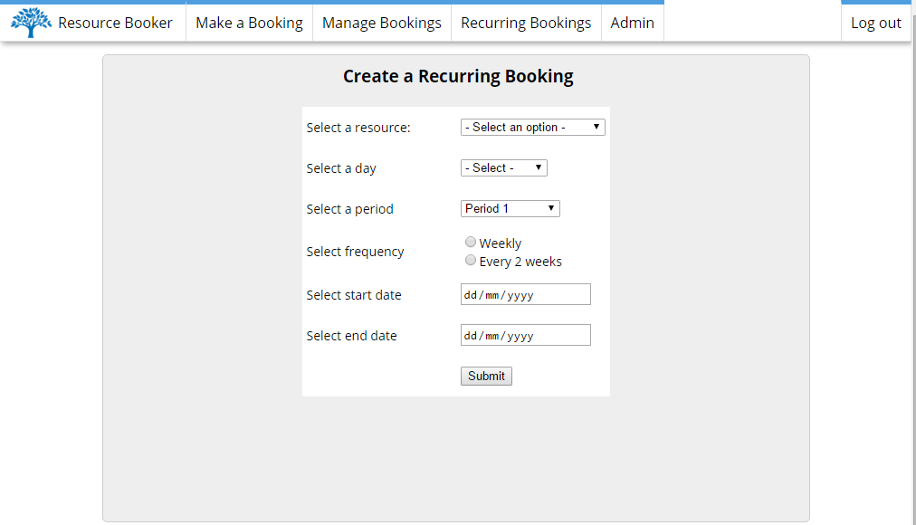

*Figure 14: The recurring booking page*

Here is where you should enter the required information for a recurring booking.

First, select the resource from the menu, followed by the day and the period.

Next, select whether you want this to recur every week or every 2 weeks. Note that by selecting every 2 weeks, the recurrence will take place on the 1st, 3rd, 5th… week, so take this into account when selecting the dates.

Now, select the start and end date for the recurrence.

Having filled out the form, and checked that the information is correct, press submit. This completes the booking, and will show you information about the booking that has taken place *(Figure 12)*.

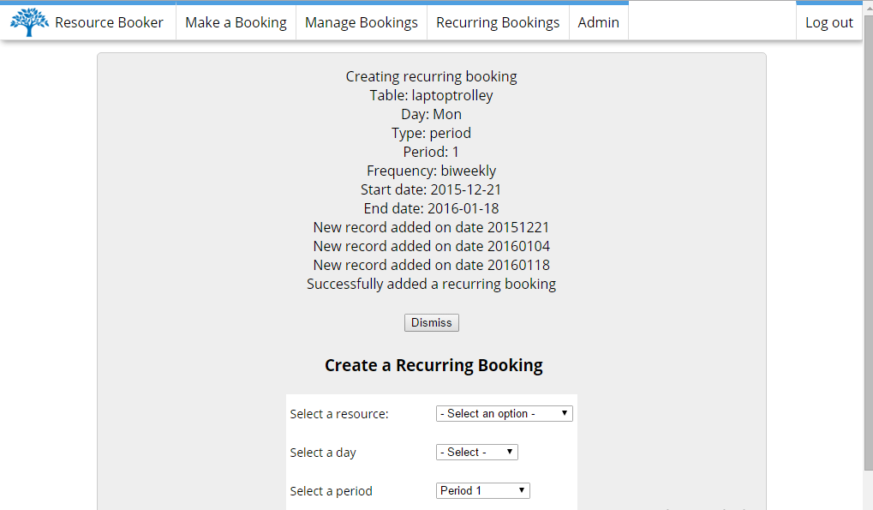

*Figure 15: The message that appears after making a recurring booking*. *Note that dates are in the format YYYYMMDD, so check that the bookings have been made for the required dates.*

## Managing Recurring Bookings

To see your recurring bookings, and to delete them if need be, select Manage under the Recurring Bookings navigation item, as shown in *Figure 13.*

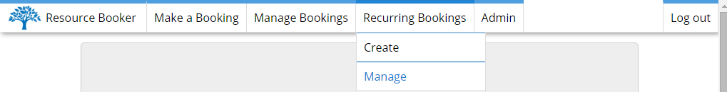

*Figure 16: The navigation menu showing where to find the Manage Recurring Bookings page*

You should be presented with a table, similar to that on the Manage Bookings page, showing all of your recurring bookings *(Figure 14)*.

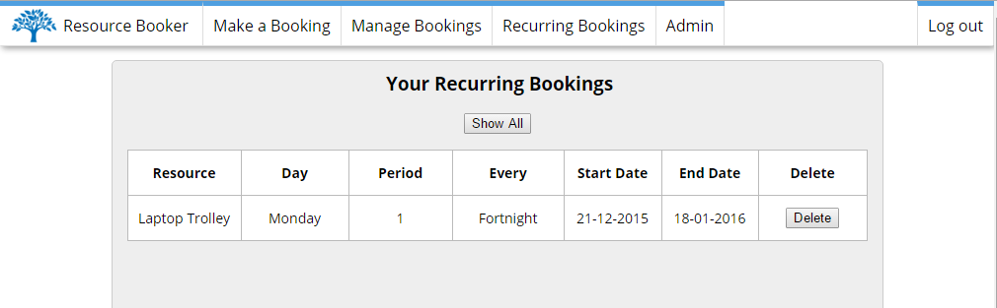

*Figure 17:* *The page for managing recurring bookings*

Here you will see your active recurring bookings.

By pressing the Delete button, you will delete all future bookings pertaining to this recurring booking. A confirmation message will appear, as shown in *Figure 15*.

Similar to the Manage Bookings page, you can press the Show All button to toggle between showing active recurring bookings, and showing all recurring bookings.

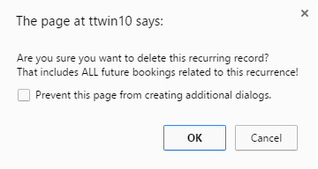

*Figure 18: The confirmation box for deleting a recurring booking*

# Logging Out

Although not necessary, logging out can be done via the Log Out button in the top right corner of the screen. Having pressed it, you will see the confirmation screen in *Figure 19*

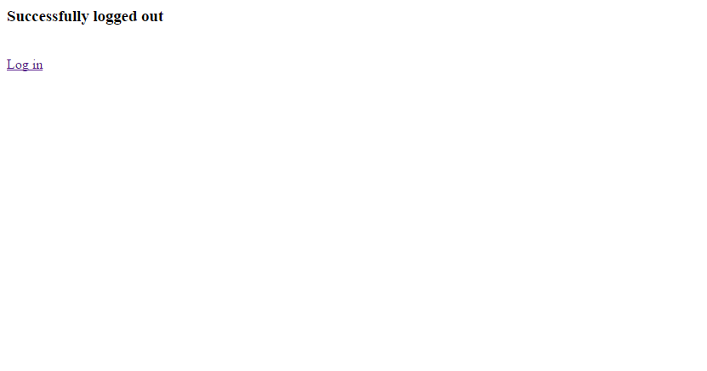

*Figure 19: The confirmation page showing that you have logged out*